**WILDERNESS VALLEY PROPERTY OWNERS ASSOCIATION, INC. INFORMATION GUIDE AND HANDBOOK**

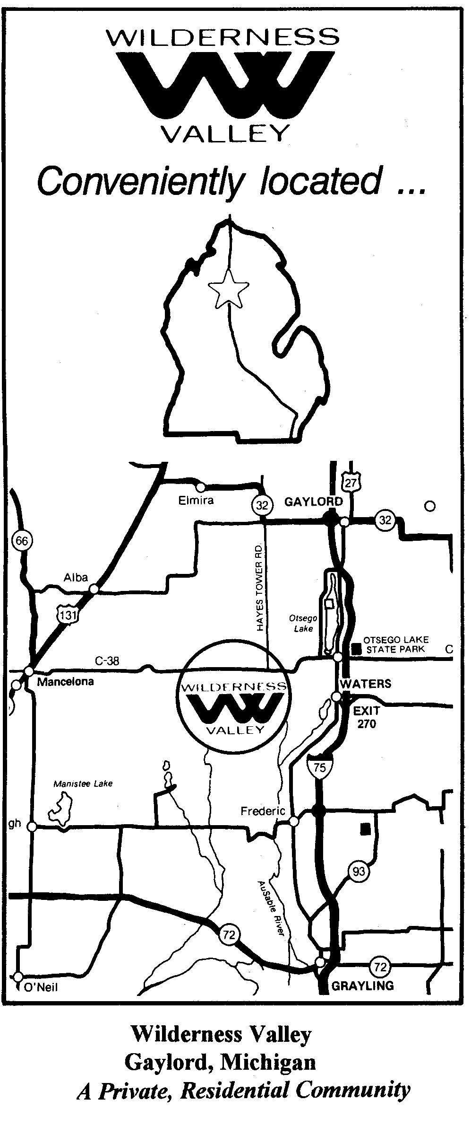

*First Printing May 2002*

*Second Printing July 2013*

*Revised January 2015*

Table of Contents

|  |  |
| --- | --- |
|  | Page |
|  |  |
| Wilderness Valley………………………………………………………………. | 3 |
| The WVPOA and The Wilderness Valley Property Owner…….……………… | 3 |
|  |  |
| Deed Restrictions……………………………………………………………… | 4 |
|  |  |
| Building Standards and Criteria…………………………………………………… | 5 |
|  |  |
| Architectural Control – Design Review…………………………………………… | 5 |
| The WVPOA Board and Building Control Committee……………………... | 5 |
| Application and Review Procedures………………………………………... | 5 |
|  |  |
| Summary of Deed Restrictions and Building Standards and Criteria…………….. | 6 |
|  |  |
| Community Services Guidelines………………………………………………….. | 8 |
| Lake Elizabeth Beach Property……………………………………………... | 8 |
| Park Property………………………………………………………………... | 8 |
| Dumpster Facility…………………………………………………………… | 8 |
| Roadways…………………………………………………………………… | 8 |
| Snow Removal Division……………………………………………………. | 9 |
| Vehicle Sticker……………………………………………………………… | 9 |
| Security Patrol………………………………………………………………. | 9 |
|  |  |
| Your WVPOA Dues and Assessments……………………………………………. | 9 |
|  |  |
| Annual Community Events……………………………………………………….. | 10 |
|  |  |
| Forest Management………………………………………………………………... | 10 |
| Guidelines…………………………………………………………………… | 10 |
| Policy……………………………………………………………………….. | 11 |
|  |  |
| Wilderness Valley Property Owners Association, Inc. By-Laws………………… | 13 |
|  |  |
| Liber 641 (Appointment of Representative)……………………………………… | 16 |
| Liber 721 (Declaration of Building Standards)…………………………………… | 17 |
|  |  |
| Application for Property Improvement and Construction Approval Form……….. | 20 |
| Application for Forestry Approval Form………………………………………….. | 21 |
|  |  |
|  |  |

**WILDERNESS VALLEY**

So you’re a Wilderness Valley property owner! Congratulations! The Wilderness Valley community extends a warm welcome to you and your family. Wilderness Valley development is a private, residential community that features attractive combinations of well-designed homes and large wooded, multiple-acre lots, shared-access facilities and plenty of scenic state land nearby. As a Wilderness Valley homeowner, you may have certain responsibilities to the development and your fellow property owners and neighbors. We are glad that you chose to make your home in our beautiful valley and look forward to your active participation as a responsible homeowner in the WVPOA.

There are many unique features that make owning a home in our Wilderness Valley community development different from traditional forms of home ownership. One is that you can share and have access to common facilities, such as our Lake Elizabeth beach and picnic area, private roadways within the entire development, and numerous other services and facilities that often are not affordable on an individual homeowner basis.

You are also able to become a member of the community’s property owners association and along with other fellow neighboring property owners, will have an important voice in the association’s decisions and how those group decisions will affect your home, property, and lifestyle in the development. A board of elected homeowner members that own property in the development governs the Wilderness Valley Property Owners Association, the property owner association group that manages, operates and maintains the Wilderness Valley development. Since each one of these board members is a resident, their main goal is to protect and preserve the development, as well as your investment in your Wilderness Valley property.

**THE WVPOA AND THE WILDERNESS VALLEY PROPERTY OWNER**

The Wilderness Valley development is governed by the Wilderness Valley Property Owners Association, Inc., or WVPOA for short. Once a developer sells all the lots in his development, management of the community is left up to the residents and property owners. A group of these residents and property owners form and establish an association, to manage and govern the development in a democratic, majority rules type of way, much like the way our founding fathers set out to manage and operate our country. Both the developer and the property owners operate the Association with the help and advice of others, such as accountants, attorneys, and public officials.

The WVPOA is a private, non-profit organization, in which all property owners must be allowed to be members. Each property owner in the development has certain rights and obligations regarding their property, and since one of those rights, and the most important, is the right to be heard and have a voice when it comes to voting on inevitable changes that affect the property owner and his investment cannot be denied.

The WVPOA is represented and governed by an elected group of nine resident property owners, known as the Board of Directors. These Board members appoint four members out of this group of nine to serve on the Board as officers. The four officer’s positions are President, Vice President, Treasurer, and Secretary. Each officer has certain duties and responsibilities they must fulfill in accordance with the Association’s by-laws. By-laws are the rules voted in effect by the majority of the Association members.

The major goal of the Board is to protect property valuations within the development and preserve the overall beauty and numerous amenities the development has to offer. This is accomplished by the implementation and enforcement of the deed restrictions, building standards and other policies in effect. The Board also provides and oversees a low-cost rubbish collection facility, snow removal services, private road maintenance, and common recreational areas for the enjoyment and use of all its members. These services are offered at a rate far below what the individual home or property owner would have to pay normally, since all the members in the Association and community share a small portion of the total overall cost. The WVPOA Board also has other duties and responsibilities such as setting up an effective communication system among members through annual meetings and the Association “e-blast” via email. The Board must also establish sound financial and record keeping practices, practical budgets and assessments, and collect assessments and dues from all members and property owners.

Specialized committees comprised of Board and Association members are formed when necessary to help govern the development. Current committees include:

* Building Control Committee – Review building applications and recommend to Board for approval or rejection; monitor all new construction.
* Road Committee – Monitor roads for needed maintenance, collect bids for work needed and advise Board of findings.
* Snow Committee – Collect bids for yearly plowing and monitor work done by contracted company.
* Dumpster Committee – Monitor dumpster activities for illegal dumping, responsible for keeping area cleaned up and make sure contracted company is fulfilling contract.
* Lake Committee – Responsible for maintenance and upkeep of lake property, picnic tables, dock and dam.
* Park Committee – Responsible for maintenance and upkeep of park property.
* Forestry Committee – Review Forestry Management applicants and recommend to Board for approval or rejection; monitor all Forestry Management activity.
* Special Events Committee – Oversee all annual special events which include the annual picnic, snowmobile rally, ATV/UTV rides, and other similar activities as might occur.
* Welcome Committee – Welcome new homeowners and property owners of the Valley. Make available copies of the Wilderness Valley Property Owners Association Manual and give them information on Association member benefits.

You are, as a Wilderness Valley property owner, invited and encouraged to take an active role in the governing of your community by participating where you will be most effective, even if that means just paying your dues and assessments on time and attending the annual meetings. You may also take a more active role by sharing and utilizing your talents and skills by serving on the Board or on a committee. Both the WVPOA and you will benefit.

**DEED RESTRICTIONS**

Deed restrictions are important rules in your day-to-day living in Wilderness Valley. In an association managed, deed restricted development such as Wilderness Valley, deed restrictions are legally recorded documents binding and restricting the property in certain ways. These deed restrictions “run with the land” and are assumed and binding on each and every past, present, and future owner of the property, from the original developer who created the deed restrictions, to you, as a Wilderness Valley property owner today. Deed restrictions detail each owner’s property rights and the conditions on use of the property and the rights and obligations of the property owner in the community.

For example, certain architectural criteria (building standards) must be observed. Wilderness Valley deed restrictions provide for architectural controls, which are enforced to ensure the integrity of the original community design. These building standards require that before any changes to the exterior of your home or property are done the developer’s appointed representative must approve them, which is the Wilderness Valley Property Owners Association Board of Directors. (Refer to Liber 641 included in this handbook)

There are many advantages to living in a deed restricted, association managed development like Wilderness Valley; a more attractive community, more open space and recreational facilities for you and your family to enjoy, a guaranteed voice in decisions that affect your community as a property owner and above all, protected property values. Other communities rarely offer this type of living or opportunity. Recorded deed restrictions covering Wilderness Valley can be found in various Libers and Pages at the Otsego County Register of Deeds Office, Gaylord, Michigan. See our Deed Restriction Summary included in the handbook for further information.

**BUILDING STANDARDS AND CRITERIA**

As indicated in the “Deed Restrictions” portion of this handbook, the “Wilderness Valley Corporation” had responsibilities to establish, approve and enforce building restrictions within Wilderness Valley. Liber 641, page 144, dated May 30, 1997, appoints the “Wilderness Valley Property Owners Association, Inc., its duly authorized representative for the approval of all plans and locations of all buildings, wall fences, storage tanks and other structures, including grading of parcels of real property within the real estate development for planting, driveways, walks and for, from time to time, establishing building and construction standards and criteria, as provided in or contemplated by restrictions recorded as part of instruments of conveyance located within the Wilderness Valley development.

The Wilderness Valley Property Owners Association, Inc. revised the Building Standards for Wilderness Valley on May 30, 1997 and recorded them in Liber 641 Pages 145-147. The Building Standards were then amended and recorded in Liber 721 pages 693-695 dated May 23, 1999.

ARCHITECTURAL CONTROL - DESIGN REVIEW

Wilderness Valley's deed restrictions, as intended by the original developer, provide for the establishment of architectural controls and design reviews. This design review and architectural control is administered through the enforcement of deed restrictions and established building standards and criteria by the Wilderness Valley Property Owners Association Board of Directors and the Building Control Committee.

These building standards and criteria are not set up to stifle your creativity, but rather to ensure the integrity of the original community design, therefore safeguarding and protecting property values within the development. You can paint the inside of your house bright orange with purple trim if you wish. It's only the exterior of your house, other structures and property that is of concern to the WVPOA; changes to which may affect the value of your investment and those of your neighbors for many years.

THE WVPOA BOARD AND BUILDING CONTROL COMMITTEE

The WVPOA Board’s main goal is protecting the major investment you and your neighbors have made in your Wilderness Valley property and home. To help preserve and safeguard these property values, the WVPOA Board and the Building Control Committee develops and distributes architectural guidelines, reviews and approves or disapproves all submitted plans for proposed projects or changes, and enforces adopted architectural standards. It is important that you as a Wilderness Valley property owner are familiar with these adopted architectural standards and criteria, and always inform the Board or the Building Control Committee when making any exterior changes or additions to your home or property.

APPLICATION AND REVIEW PROCEDURES

Prior written approval by the Board is a prerequisite to any new construction, exterior change or improvements to any structure or property within Wilderness Valley. The first step in the design review process is to complete a written construction application for approval, available from any Board member or our website (www.wvpoa.com), of the proposed project or change, and submit it to the Building Control Committee or any Board member. Including an Otsego County approved site plan and blueprints with your application (if available) will help speed the review process.

After review by the Board, you will receive a copy of your application, either hand delivered or in the mail, from the Board of Directors and Building Control Committee. The results of the review will be indicated on the application. Sometimes approval may be held up because additional information is needed to complete the review process.

The approval of an application will be followed by frequent inspections of the work and work site to make sure it conforms to the proposal and any approval conditions. Any unapproved project or change is prohibited, and if constructed, may result in corrective action requiring the removal of any unapproved condition. Any and all legal action resulting from the violation will be at the sole expense of the property owner.

Note: Due to legal ramifications, the Otsego County Planning and Zoning Department has clarified its policy regarding site plan review by property owner associations. "Properties within the jurisdiction of property owner associations may have additional restrictions on use. Property owners are responsible for complying with any deed restrictions. To avoid possible civil action by other property owners, please check with representatives of any property owner association." (From an Otsego County Planning and Zoning Department memo dated July 16, 1996)

In addition, Hayes Township and Otsego County ordinances affect land use in Wilderness Valley. All property owners are encouraged to contact these local governing agencies for more information.

**SUMMARY OF DEED RESTRICTIONS, BUILDING STANDARDS AND CRITERIA**

George Wellington Smith, the original developer, deeded the property in stages starting with sections 19, 20 and 21, adding sections 28, 29 and 33 in later years of Hayes Township, Otsego County, Michigan. Since some parcels within the Wilderness Valley development have slight variances in their restrictions, the following is a compilation and summarization of significant deed restrictions applicable to prospective property owners of all property in all sections within Wilderness Valley. Deed restrictions are covenants running with the land binding on the heirs, legal representatives, and assigns of the Grantor and the Grantees of the lands thereof, therein known as "Wilderness Valley."

All lots in the area known as Wilderness Valley shall be used exclusively for residential purposes. "Lots" herein described are ten (10), five (5), and two and one-half (2.5) acre parcels and combinations of the aforementioned. No structure or building shall be erected, altered, placed or permitted to remain on acreage other than single family dwellings, attached and unattached garages and ancillary storage buildings used in connection with the single family dwelling. Any dwelling erected, altered, or placed upon the properties in Wilderness Valley must be approved in writing by the Wilderness Valley Property Owners Association Board of Directors or the Building Control Committee prior to the start of any construction.

ALL STRUCTURES - MINIMUM STANDARDS

* Any residence erected or placed upon the property shall have not less than 1000 square feet for a single-story dwelling and not less than 1500 square feet for a multiple-story dwelling of enclosed living space exclusive of basement or any below grade areas, porches, breezeways, carports, patios, pool areas, garages and other accessory uses areas.
* All roof pitches must be 6/12 or greater, unless approved in writing by the Building Control Committee.
* A single story dwelling shall be at least thirty (30) feet wide at foundation level and built at least two (2) feet above grade unless approved in writing by the WVPOA Board.
* In no cases shall a temporary structure be permitted as a residence or as a temporary residence without prior written WVPOA Board approval and Otsego County Zoning permit. This includes trailers, mobile homes, recreational vehicles, campers, tents or any other structure not affixed to a permanent foundation.
* No more than two (2) single detached buildings for occupancy by property owner or guests, and no more than two (2) private ancillary storage structures per lot.
* No building or structure shall be erected, located, or placed nearer than (35) thirty-five feet from any lot line, or nearer than fifty (50) feet from the center line of any roadway. Eaves, steps, and open porches shall be considered as part of the structure for purposes of this paragraph.
* All existing roadways utilized in conjunction with and damaged or deteriorated during any type or phase of construction must be restored to their original good, usable condition, and restoration is the responsibility of the property owner performing the construction.
* All roadways within Wilderness Valley, described in Sectional maps and Plats, are to be kept open and usable at all times. Blocking existing roadways is strictly prohibited. Any cutting of trees and/or shrubs or removal of them is prohibited, except where necessary in building, or where they are in a dangerous condition, with written approval of the WVPOA Board.
* All structures constructed must be completed on the exterior within one (1) year from the start of construction, or from when a foundation or footing has been dug. All structures must adhere to the Otsego County Zoning and State Health Codes or any other agency governing their construction and use.
* All buildings and structures shall be erected according to the Otsego County Building Codes under Michigan Amended B.O.C.A. Codes.
* No commercial signs, posters, billboards, road signs, or advertising of any sort shall be permitted on any lot or building thereon unless with prior WVPOA Board approval.

OTHER DEED RESTRICTIONS

* The dumping or accumulation of trash or rubbish shall not be permitted on any property. Refuse, ashes, garbage and debris of any kind shall be cared for in such a manner as not to cause an unsightly appearance, nuisance or health hazard.
* No livestock, poultry, or animals of any kind shall be raised, bred or kept on any lot, except for dogs, cats, and other ordinary household pets.
* No lot shall be subdivided without prior written WVPOA Board approval.
* The WVPOA will maintain all existing roadways within the Valley currently servicing existing home sites, which is accomplished through annual solicitation of the assessment of funds from all Wilderness Valley property owners. The WVPOA will not construct new roadways or rebuild existing roadways in poor condition not currently serving existing home-sites, and all alterations to existing roadways must have prior written Board approval.

Enforcement of the above deed restrictions shall be by any proceeding at law or in equity against any person or persons violating or attempting to violate any restriction as recorded in these deed restrictions, as deemed necessary by the WVPOA Board of Directors.

**WVPOA COMMUNITY SERVICES GUIDELINES**

All community services listed below are offered by the Wilderness Valley Property Owners Association and are available through the WVPOA to all Wilderness Valley property owners upon payment of the annual association dues and assessments. All association members are asked to use these community services and their facilities wisely and responsibly. Contact any board member listed in the appendix for more information.

LAKE ELIZABETH BEACH PROPERTY

Current year annual vehicle permit required for use.

No lifeguard present – swim at your own risk.

No fishing from dock or beach area.

Camping and campfires are strictly prohibited.

No gas powered boats allowed on lake.

Help keep area clean at all times.

Use restricted to members and their guests only.

Pets must be leashed at all times and any droppings picked up and disposed of properly.

PARK PROPERTY

Current year annual vehicle permit required for use.

Camping and campfires are strictly prohibited.

Help keep area clean at all times.

Use restricted to members and their guests only.

Pets must be leashed at all times and any droppings picked up and disposed of properly.

DUMPSTER FACILITY

Use of dumpster is only for residents who have paid the current annual service fee.

Place all rubbish inside of dumpster – do not leave trash outside or around dumpster.

All rubbish must be in garbage bags. Break down all boxes.

Household garbage only.

No building materials, machinery, hazardous waste or chemicals, furniture, appliances, etc. are allowed.

No lawn clippings, leaves, or brush.

Place your bagged garbage in rear of dumpster when possible.

Since the above guidelines involve strict safety and environmental laws, anyone seeing misuse of the dumpster facility is to report it to any board member listed in the appendix of this booklet. All violators may be fined and facility privileges revoked.

ROADWAYS

All roadways in Wilderness Valley are private with the exception of Mt. Frederick, Geronimo’s Trail, Deward Trail, Coyote Run and Tittabawassee, which are County owned and maintained. The maintenance of all private roads in Wilderness Valley is the responsibility of the individual property owners, and is accomplished by the annual solicitation and collection of road assessments on each property owner. Road assessments for those property owners in the development who live on a county road are assessed at ½ of the normally charged rate.

Anyone noticing road conditions needing maintenance is asked to contact any board member. For the safety of our residents, their children, guests, pets and our wildlife, please obey all posted speed limit and other cautionary road signs. Please drive in a responsible and alert manner, especially in areas of limited sight distance, such as around curves, over hills, and along roads made narrow by trees and brush. Speed should be kept to a maximum of 25 miles per hour in residential areas, and lower speeds during snowy and icy conditions.

The road fund revenues are used for maintenance only, and do not include building or major improvements of existing roadways.

**SNOW REMOVAL DIVISION**

With the exception of Tittabawassee, Geronimo’s Trail, Mount Frederick and Deward Trail, which are county maintained, all roads in Wilderness Valley are private; therefore, are not plowed or maintained by Otsego County. After the formation of the WVPOA Inc., its members voted to form a Snow Removal Division for the purpose of providing snow removal on the Valley’s private roads. Prior to that time each homeowner had to arrange plowing from their house to a county road. Membership in the Division is open to all members of WVPOA, Inc., who have paid the annual fee and are in good standing in the Association.

A pro-rated fee per homeowner was estimated, using previous years costs, and will be billed to each homeowner living on a private road in Wilderness Valley. Over the years approximately 80% of the homeowners pay for snow plowing. Those not participating may be doing so because they do not use their home during the winter or they live on a road that allows them to plow themselves. Some of the non-paying homeowners may be taking advantage of the service provided. By doing so, the pro-rated fee increases for the homeowners paying their share. It is important that we recognize the need to keep all roads open and accessible in case of emergencies such as fire or rescue services. Where possible, snow plowing will not be done leading to a non-paying homeowners residence.

The board encourages every homeowner to pay their fair share of the snow removal costs and encourages their neighbors to do the same to make it equitable for everyone.

VEHICLE PERMIT STICKERS

Vehicle permit stickers are issued to members on an annual basis who have paid the membership dues and assessments.

Display on front passenger’s side windshield

Discard any previous years’ vehicle permit sticker.

SECURITY PATROL

For the protection of its services and facilities, the WVPOA security personnel will make routine patrols of the Wilderness Valley development. Anyone wishing to report a concern or problem is asked to contact any board member listed in the appendix.

**YOUR WVPOA DUES AND ASSESSMENTS**

An association managed development such as Wilderness Valley relies on the financial support of each property owner. This financial support, collected from each property owner in the form of annual dues and assessments, enables the WVPOA to remain financially sound, and maintain its services and facilities.

The WVPOA Board of Directors, comprised of up to nine annually elected resident property owners, are the volunteers who shoulder this large financial responsibility for the entire community, and who oversee its management and operation. You can show your support for the Board's volunteer efforts to oversee the Wilderness Valley development by paying your dues and assessments promptly each year. These revenues help the Board to operate effectively and efficiently in maintaining and managing your community.

Every Wilderness Valley property owner shares in the many benefits of being a member of this development, and clearly recognizes their individual responsibility for sharing the overall costs of the community’s upkeep.

The following dues and assessments are effective as of January, 2015, and due annually in the month of May:

ACTIVE – (If you own a home in the Valley)

Membership dues - $40.00

Road assessment - $100.00 (private Road)

$50.00 (county Road)

ASSOCIATE – (If you are a property owner only)

Membership dues - $20.00

Road assessment - $25.00

Your paid membership dues entitles you to use of the Lake Elizabeth beach and picnic area, and all membership privileges and voting rights in all WVPOA issues.

Other services available to paid up members:

* Dumpster facility use - $65.00
* Snow Removal Service - $125.00 (or slightly higher depending on snowfall amounts)

**ANNUAL COMMUNITY EVENTS**

* ATV/UTV ride – Tour the Valley during the fall color season. A great time for family and friends.
* Snowmobile Outing – January event for all snowmobile enthusiasts. A beautiful, breath-taking 2-3 hour ride through the Valley and surrounding picturesque areas.
* Picnic – Event of the summer at Lake Elizabeth. Family and friends welcome for good food and a fun afternoon. Everyone brings a dish to pass and the WVPOA supplies the hamburgers, hot dogs and condiments. A great time to meet or renew acquaintances with our other members.

**FOREST MANAGEMENT**

GUIDELINES

One of the major benefits of Wilderness Valley is the serenity of our forestland. Certainly, an objective of the WVPOA is to ensure the preservation of this valued natural resource and to guard against any damage or abuse. Our forest, mostly consisting of hardwoods, is ever changing and we can enhance the quality of our forest with proper forest management techniques. One method to improve future timber growth and quality is to periodically conduct selective harvests and thinning of trees. The objectives of selective harvests and thinning are:

* To develop a quality forest stand by removing defective, damaged and otherwise undesirable trees, thus concentrating growth on fewer, high quality trees. Defective, damaged, diseased or deformed trees occupy growing space and compete with the better trees for moisture, sunlight and soil nutrients. Removing them from the stand will allow desirable trees to grow more rapidly. Promote the growth of more desirable trees. Some trees considered to be more desirable (for aesthetic value and wildlife benefits) are the American basswood, white ash, sugar maple, red and white oak, and American beech.
* Many woodlots contain too many trees for maximum growth. Although the stand may be composed of desirable trees, competition among the trees for available growing space can be severe; therefore, thinning is needed to regulate spacing among trees so maximum growth can occur.
* In addition to forest health, thinning can also have a positive effect on wildlife and the environment. It can provide snags for woodpeckers, wood debris for biodiversity, firewood, and income. Selective harvests and thinning operations can be favorable to our forest only by using the best forest management practices. Improper methods can seriously damage a stand, which will have long lasting negative effects on the stand, as well as property values, and may take years to reverse.

FOREST MANAGEMENT POLICY

All Wilderness Valley property is eligible for selective harvesting or thinning operations. Property owners must submit an application to the Board outlining their intentions to conduct selective harvesting or forest thinning operations. The primary purpose of this process is to ensure the property owner thoroughly understands all the policy requirements.

The board strongly advises against using a logger to provide the services of a forester and conduct the logging operation. Doing so can produce a major conflict of interest regarding the property owner’s desires and responsibilities under the policy. We recommend using a registered forester, especially if you have no experience in this area. Property owners are required to provide a report of findings or a forest management plan to the board, normally completed by a Registered Forester, stating their assessment of the property and their recommendation for properly managing the property based on best forest management practices identified in Michigan’s Sustaining Forestry Education Guidelines. A draft copy of the timber sales contract must also be submitted to the board for approval prior to any cutting.

The contract shall contain and not be limited to the following:

* The types of trees to be removed must be specified and the **maximum percentage of trees to be removed is 35%**, unless the Forester provides compelling reasons to exceed that. Selection of multiple tree species and diameters to an optimized target area (target basal area of 70 – 90 square feet) is recommended.
* **Harvesting only single tree species and diameter limits will not be approved.**
* **High grading (taking only the best trees) will not be approved**.
* **Massive clear cutting is NOT permitted**. The only exception is to treat stands that are diseased, insect or other pest infested. Small sections (less than one acre per ten acres) of clear cutting are permitted only for the regeneration of shade intolerant tree species (like aspen or jack pine) where the conversion to a more long-lived species is not possible.
* Type of operation defined – chipping and/or bolts. If a “topping” type of logging operation is being conducted, the remaining limbs or slash shall not exceed three inches in diameter. The slash must also be cut up enough to have a clean and uncluttered appearance. Small piles of slash are permitted for wildlife habitat.
* The property boundaries must be accurately and clearly marked.
* A harvest site sketch must be provided showing the location and the size of the equipment landing area and skidding trails and the areas to be thinned.
* Only marked trees will be cut.
* Stump heights shall not exceed 12 inches.
* Spring poles and hung trees shall not be allowed and must be brought to the ground. Some hung trees should be left for wildlife habitat.
* The access roads used by the loggers must be specified.
* All roads shall be maintained to the original good condition following the operation.
* The impact on soil erosion must be specified.
* The property owner should ensure the logger has proper insurance including comprehensive liability coverage. The WVPOA assumes no responsibility for damage to property or personal injury or death resulting from the tree thinning authorized.
* The overall harvest site must have a clean appearance following the operation.

Upon board approval of the timber sales contact, the contract can then be bid. The property owner is responsible for obtaining all necessary permits required by Otsego County. The forester can then select and mark trees for harvesting by using paint or ribbon. Such marks must be on the trunk and stump, and still remain after the cutting, so that the board may review the harvested trees. Only marked trees can be cut. The property owner grants permission for board members to enter the property for purposes of inspecting the work for contract compliance. The property owner is responsible for the repairs of any and all roads damaged by logging equipment. The owner assumes responsibility if they approve the operation and dismiss the logger.

The property owners shall provide themselves, or secure from the company hired to do the work, a bond in the amount of $5,000.00. Said bond shall be forfeited to the Wilderness Valley Property Owners Association, if any of the following should occur, whether intentional, or not in the following:

* Contract requirements are not met
* Cutting exceeds amount approved in application.
* Cutting exceeds trees that were marked.
* Damage to roads, caused by logging equipment, is not repaired.

The property owner shall sign, and have notarized, an agreement with the Wilderness Valley Property Owners Association Board of Directors, indicating his/her agreement to these terms. Said agreement shall be executed prior to the start of timber harvest.

*Optional.* The board strongly recommends consulting with a registered Forester to provide the following services (note – all Foresters charge a fee and/or collect a percentage of the timber sale revenue for their services):

* Assess the property and recommend a forest management plan.
* Prepare a timber sales contract.
* Obtain bids for the harvest and select a logger.
* Select and mark trees for harvesting.
* Ensure compliance of the contract before, during and after the logging operation.

The following is a current list of area foresters who may be of assistance (updated January 2015).

|  |  |
| --- | --- |
| Geoff Kegerreis  Timberline Forestry Consulting LLC  Leroy, Michigan 49655  (231) 920-1007  Ivan Witt Forestry Consultants, Inc.  5105 Nowak Rd.  Gaylord, MI 49735  (989)983-3024  (989)370-9754 | Jerry Lambert  Forest Resource Services, LLC  6223 Hayes Tower Rd.  Gaylord, Michigan 49735  (989) 732-7188 |

**WILDERNESS VALLEY PROPERTY OWNER’S ASSOCIATION, INC BY-LAWS**

*(Revised July 1, 2000)*

***Article I***

Purpose

To promote a spirit of cooperation among all of the property owners in the development known as “Wilderness Valley,” for their mutual benefit and protection. To gather, receive and disseminate such information as may be helpful to its members. To interchange ideas in rendering mutual assistance. To aid in the enforcement of existing general restrictions applicable to the “Wilderness Valley” development, as recorded in the Register of Deeds, County of Otsego, together with such amendments thereto as may be hereafter imposed with the consent of the members of this Association.

***Article II***

Membership

Membership in this Association shall be divided into two classes:

1. Active Membership
2. Associate Membership.

Active membership is open to all owners of improved tracts in both Wilderness Valley No. 1 (so called) and the replatted Wilderness Valley no. 2, according to the plat thereof as recorded in Liber 212, Pages 332 thru 334, Otsego County Records and shall become a member upon payment of the annual dues. An improved tract, as used herein, is a tract on which there exists a permanent structure, meeting WVPOA Building Standards and Criteria,for occupancy as a dwelling place.

* + One active membership entitles owner(s)to attend meetings and hold office. However, only one vote per active membership is permitted. AnActive membership may designate a proxy in writing to cast its vote at any meeting of the membership.

Associate membership is open to owners of unimproved tracts and renters of improved tracts, in both Wilderness Valley No. 1, (so called) and the replatted Wilderness Valley No. 2, according to the plat there of, as recorded in Liber 212, pages 332 thru 334, Otsego County Records and shall become a member upon payment of the annual dues.

* + One associate membership entitles owner(s)to attend meetings and to cast one-half vote per associate membership. Associate members shall not have the right to vote by proxy at any meeting of the membership.

The fiscal year of the Association shall begin on the first day of June of each year and shall end on the 31st day of Mayof the following year. The Board of Directors with the approval of the membership shall determine the annual dues for Association membership. The Association voting membership shall be empowered to level special assessments against the members of the Association when necessary to accomplish the purposes of the Association.

***Article III***

Meetings

The annual meeting of the membership shall be held within 60 days after the start of the Associations new fiscal year (June 1st),at such time and place as the Board of Directors shall designate, notice of which shall be given to the membership as hereinafter provided, for the election of officers and for the transaction of such other business as may be brought before the meeting.

After the annual meeting of the membership, the Board of Directors shall elect a President, Vice-president, Treasurer, and Secretary, each of whom must be an active member of the Association and a current Board member.

Special meetings of the membership may be called by the Board of Directors on notice to the membership as hereinafter provided or upon the written request of a majority of the active members of the Association duly transmitted to the secretary. Notice of the time and place of the special meetings shall be given as provided below, together with the stated matters to be considered thereat.

Notice of the time and place of the Association annual meeting of the membership shall be served by mail on each member not less than twenty (20) days prior to the meeting. Special meetings may be held upon fourteen (14) days written notice.

Fifty-one (51) percent of the Association’s active membership must be present in person or by proxy in order to constitute a quorum. Meetings of the membership shall be presided over by the president of the Association or, in his absence, by the vice-president. Robert’s Rules of Order shall govern the conduct of the meetings. All elections or questions shall be decided by the affirmative votes of a majority of the active members present or represented at the meeting.

***Article IV***

Board of Directors

Its Board of Directors, which shall consist of not less than three (3) and not more than nine (9) members, each of whom must be an active member of the Association, shall manage the property, business, and affairs of the Association. All members of the Board shall be elected for one-year terms at the annual membership meeting to serve until their successors are elected and qualified.

A minimum of one year shall be required as a member of the WVPOA in order to be eligible for nomination as a Board member.

A majority of the members of the Board of Directors shall constitute a quorum for the transaction of business.

The remaining directors at any regular or special director’s meetings may fill vacancies in the Board of Directors, but the director so selected shall hold office only until the next annual meeting of the membership.

Meetings of the Board shall be held from time to time as deemed necessary or desirable in order to administer the affairs of the Association. The secretary shall give notice to all Board members by e-mail or telephone within reasonable time prior to the meeting, which notice shall specify the time, place and agenda of the meeting insofar as practicable.

The Board of Directors shall have authority to open bank accounts in the Association name and to designate officers to sign checks against such account and to make expenditures of Association funds in furtherance of its purposes and for the general benefit. The Board may engage such agents, as it deems necessary to aid in the accomplishment of the purposes of the Association. The Board shall not incur indebtedness on behalf of the Association beyond the funds on hand in the Association’s treasury without the approval of the membership at a meeting duly held. The Board shall be responsible for negotiating and providing services as requested by the membership and may, upon affirmative vote of the majority of the active members, impose and collect special assessments on the membership on terms and conditions as approved by the majority of such active members. The Board shall have such other and further general powers and responsibilities as may be reasonably necessary to protect the general membership and to fulfill the requirements and purposes of this Association.

***Article V***

Officers

All officers shall serve for terms of one year or until their successors are elected and qualified at the succeeding annual meeting. Any officer may be removed for cause at any time during his/her term by an affirmative vote of two-thirds of the members present at a duly called special meeting of the Association. In case of removal, the office so vacated shall be filled by majority vote of the members present. In the event an office is vacated by resignation or death, a majority vote of the Board of Directors shall fill the unexpired term thereof.

The officers of the Association shall serve without compensation except to the extent authorized or approved by resolution of the membership of the Association.

The president shall be the chief executive officer of the Association and shall preside at all meetings of the membership and of the Directors. He /sheshall have general and active management of the business of the Association and shall see that all orders and resolutions of the membership and of the Directors are carried into effect.

The vice-president shall, in the absence of the president, have all the powers and duties of the president.

The secretary shall, except as otherwise designated by the Board of Directors, attend all meetings of the Board and of the Association membership and record all votes and keep the minutes of all proceedings in a book for that purpose. He/she shall give or cause to be given notice of all meetings of members and special meetings of the Board, and shall perform such other duties as may be prescribed by the Board. The secretary shall generally perform other further duties as may be designated or as are usually incident to the office of secretary.

The treasurer shall have the custody of the Association funds and securities and shall keep full and accurate accounts of receipts and disbursements in a book belonging to the Association and shall deposit all moneys and other valuables in the name and to the credit of the Association in such depositories as may from time to time be designated by the Board of Directors. He/she shall render to the Directors and annually to the general membership a full and complete account of all transactions as treasurer and of the financial condition of the Association.

*Parliamentary Authority*

The rules contained in the modern edition of Roberts Rules of Order shall govern the Association in all cases where they are not inconsistent with these bylaws and any special rules of order the Association may adopt.

***Article VI***

Amendments

The by-laws may be altered or amended upon the affirmative vote of two-thirds of the members entitled to vote at an annual meeting or a special meeting, if a notice of the proposed alteration or amendment is contained in the notice of such meeting.

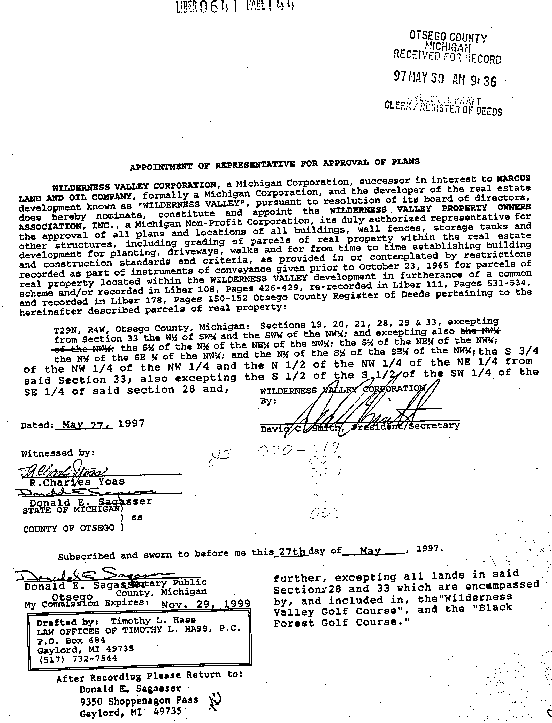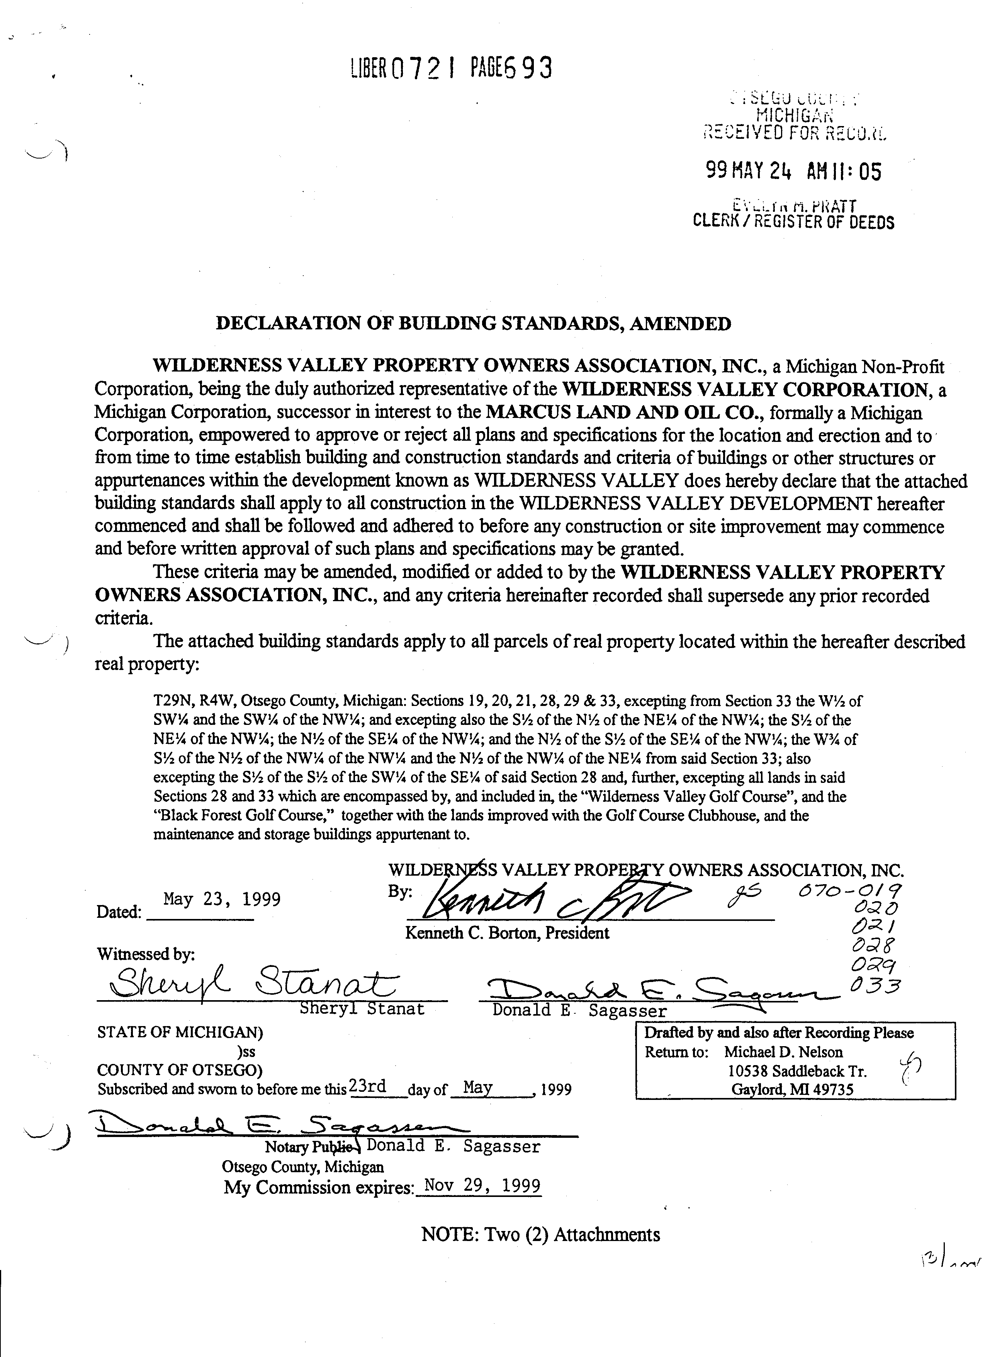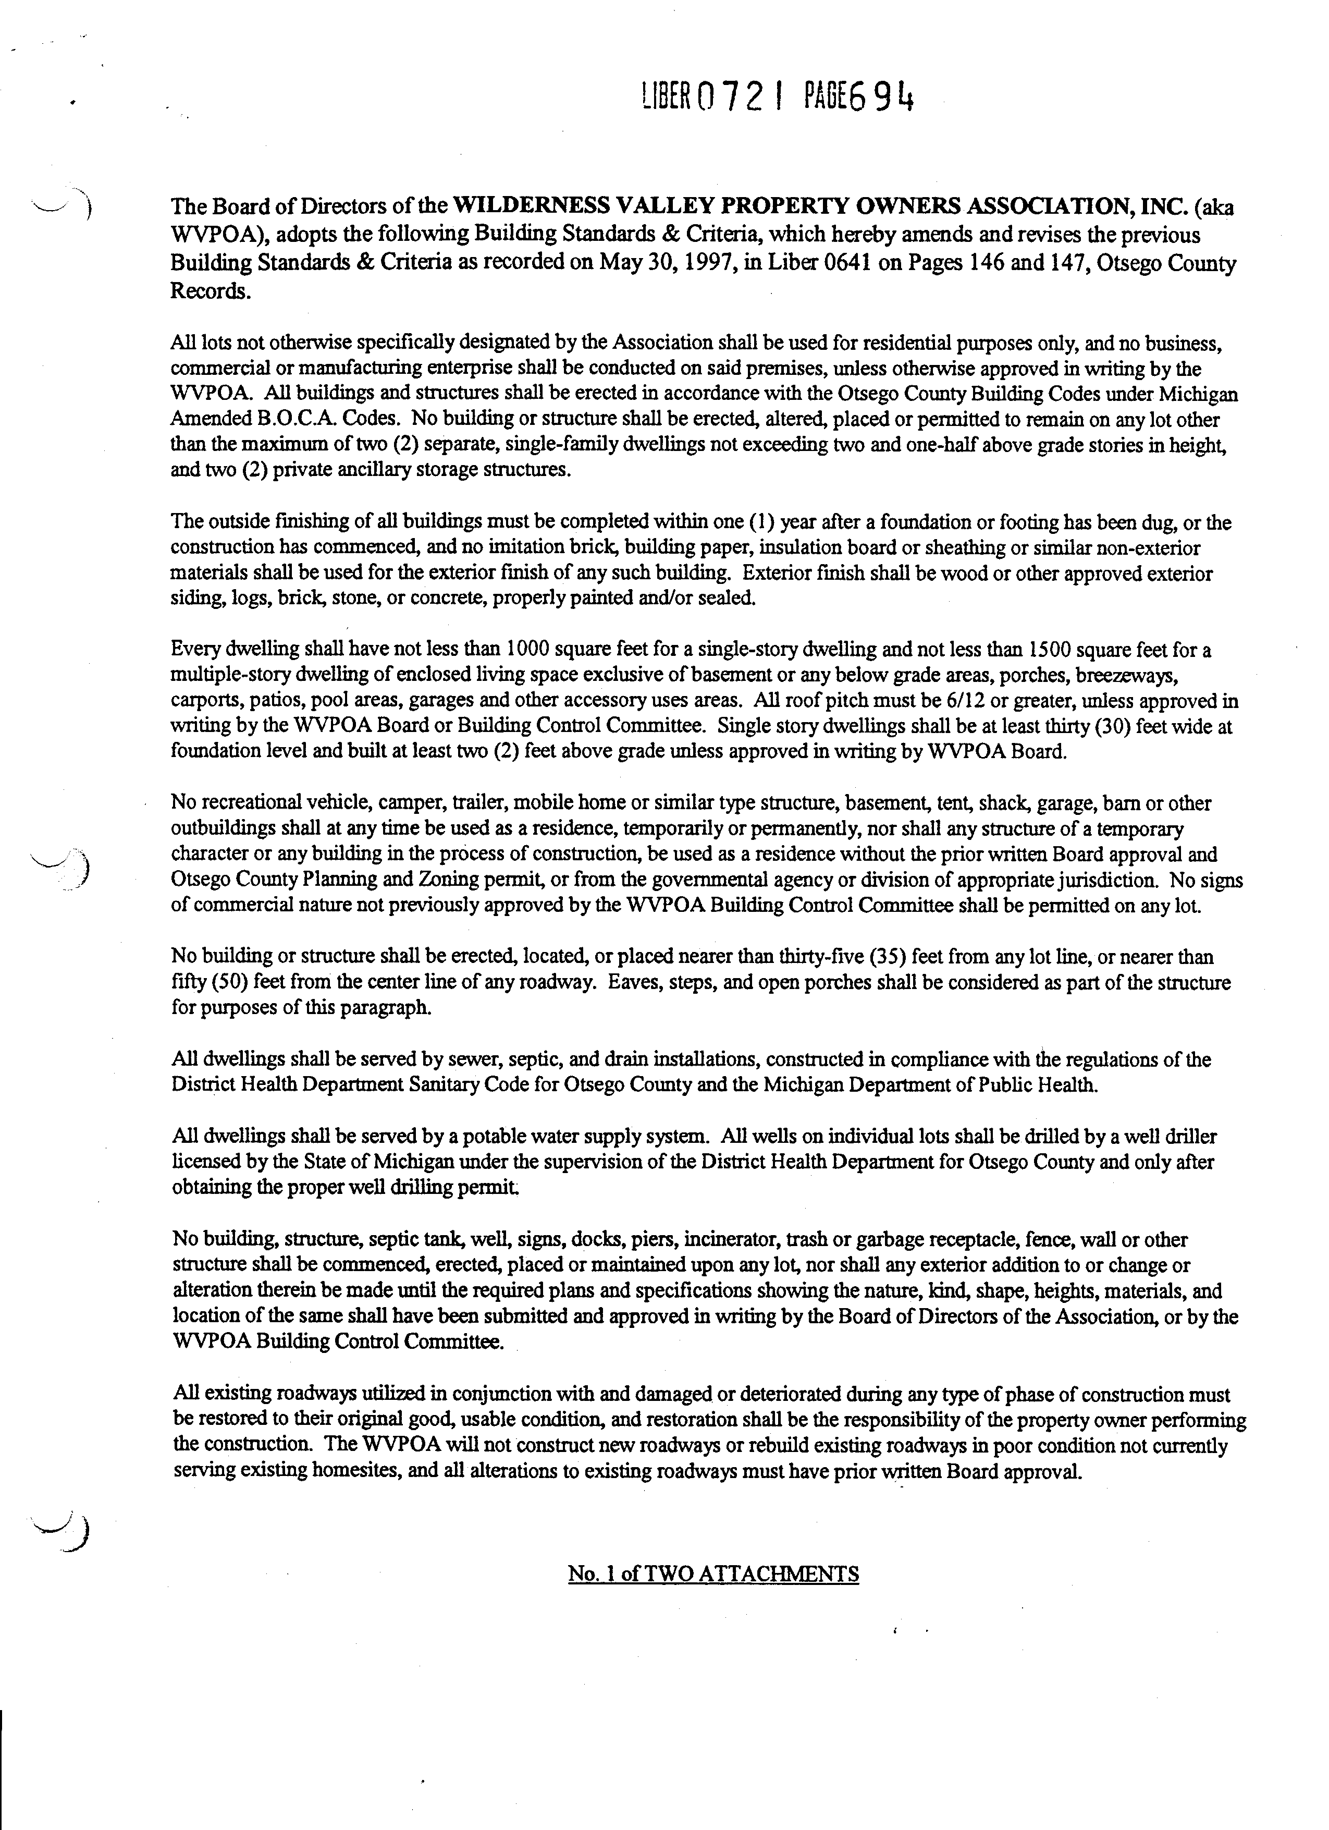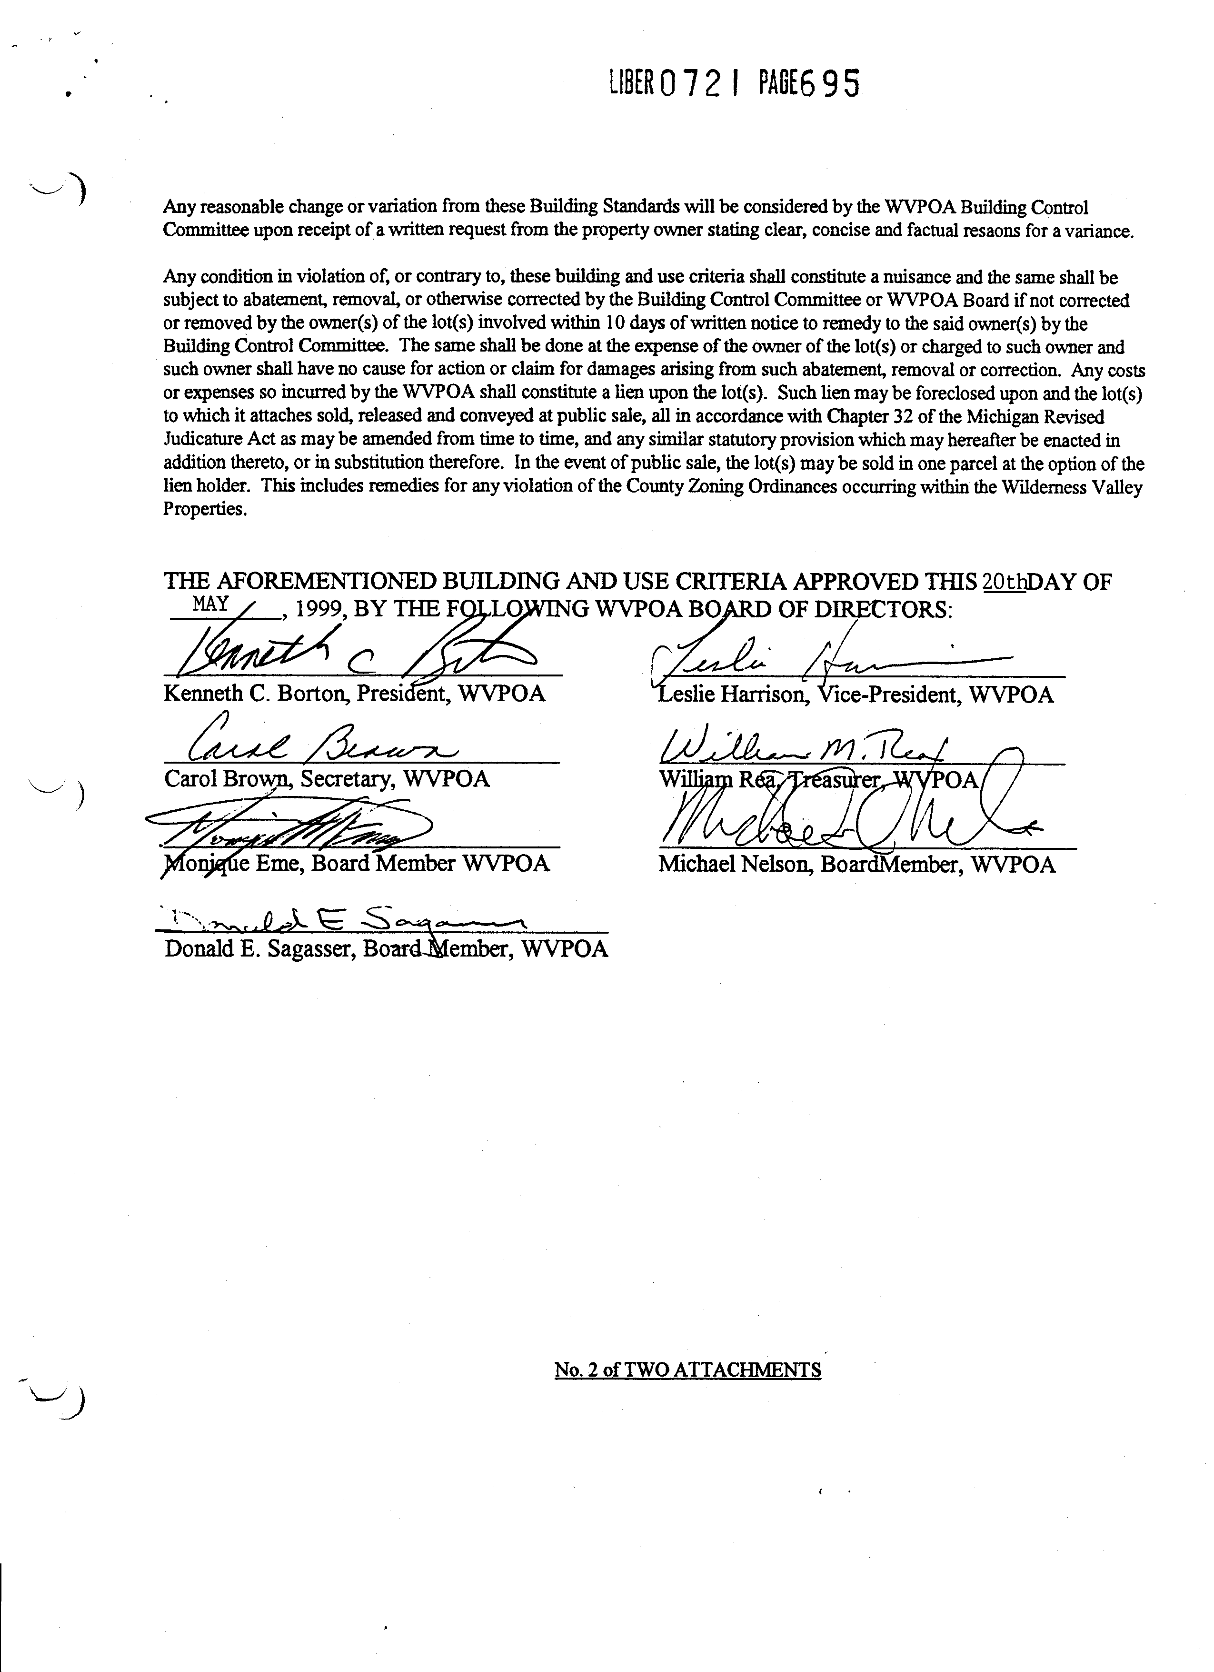

WILDERNESS VALLEY PROPERTY OWNERS ASSOCIATION

P.O. BOX 871, GAYLORD, MI. 49734

**Application For Property Improvement and Construction Approval**

Date Submitted:________________________________ Tract Numbers:________________________

Property

Owner’s Name: _________________________________________Phone:_________________________

Address:______________________________________________________________________________

(Street) (City) (State) (Zip)

Builder’s Name:________________________________________ Phone:_________________________

Description of tree removal and clearing:___________________________________________________

|  |
| --- |
|  |

Type Of Construction: ( ) New Residence ( ) Addition ( ) Outbuilding ( ) Renovation

( ) Other Explanation_______________________________________________________________

|  |
| --- |
|  |

Total Square Feet: __________________ Exterior Construction Material:_________________________

Additional Details Pertinent to Approval:____________________________________________________

|  |
| --- |
|  |

Please submit a copy of blueprints and an Otsego County approved site plan showing building setback distances from all property lines with this application.

Building Control Committee Approval:_________________________________ Date: ______________

WVPOA Board Review: ____________________________________________ Date: ______________

Comments and / or Conditional Approval:___________________________________________________

_____________________________________________________________________________________

Approval Letter sent to applicant by: ___________________________________ Date: ______________

Applicant must advise the Building Control Committee of any changes prior to the start of any construction.

All site work and exterior of all buildings must be completed within one year of the date of this approval.

This approval expires one year from the date of approval.

Applicant must also abide by Otsego County – Hayes Township Zoning Ordinances and Laws.

Submitting this completed form allows the Building Control Committee to inspect the premises for verification of information.

I have read, understand and will adhere to all land use and deed restrictions for Wilderness Valley.

______________ ______________________________________________________

Date Property Owner’s Signature

*\*\*Please return this completed form along with blueprints and site plan to the address above.\*\**

WILDERNESS VALLEY PROPERTY OWNERS ASSOCIATION

**P.O. BOX 871 GAYLORD, MI. 49734**

# Forestry Application Approval Form

#### Any Wilderness Valley property considered eligible for selective harvesting or thinning operations must comply with the WVPOA Forestry Management Policy dated December 2009. Owner of property agrees, by signing below, to fully abide by all rules/restrictions in **WVPOA Forest Management Guidelines** pursuant to onset of any forestry operations.

## Date Submitted: ________________________________ Tract Numbers: _________________________________

Property Owners Name: _________________________________________ Phone: _________________________

## Address: _____________________________________________________________________________________

(Street) (City) (State) (Zip)

Forester Name: _________________________________________ Phone: ________________________________

**The following must be submitted and approved by the Wilderness Valley Property Owners Association, Inc., before any forestry operation may proceed either by Landowner or Forester on behalf of Landowner:**

1. Report of findings or a forest management plan (normally submitted by a registered Forester stating assessment and recommendations).
2. A draft timber sales contract containing but not limited to the following:
   1. Types of trees to be removed and maximum percentage (no more than 35% allowed unless compelling reasons are given to exceed this amount).
   2. Type of operation defined, i.e. topping, chipping, bolts.
   3. Property boundaries accurately and clearly defined.
   4. Access roads used specified.
   5. Any other information pertinent to forestry plans.
3. Harvest site sketch.
4. **Performance Bond in the amount of $5,000.00, which will be forfeited to the Wilderness Valley Property Owners Association, Inc. if not forested in accordance with the WVPOA Forestry Management Policy.**

***I have read the WVPOA Forest Management Procedures , Policy and Guidelines and will abide the rules and procedures therein.***

Property Owner Signature________________________________________________Dated__________________

WVPOA, Inc. Board Member Approval:

_______________________________________ _______________________________________

_______________________________________ _______________________________________

_______________________________________ _______________________________________

_______________________________________ ________________________________________